Department of Computer Science
Gujarat University
MCA sem2
Assignment for unit 3,4,5

- Define Knowledge Representation and its importance in AI.
- What is a Semantic Network? Give one example.
- Differentiate between: Propositional Logic vs Predicate Logic
- What is Conceptual Dependency?
- Define Forward and Backward Chaining.
- What are Predicates and Functions in logic?
- Explain Procedural vs Declarative Knowledge.
- List the steps of NLP.
- What is a Perceptron?
- Define Expert System with one real-life example.
- Explain Knowledge Representation Techniques:
Semantic Networks
Partitioned Semantic Networks
Conceptual Dependency
Rule-based systems
- Discuss advantages and limitations of Knowledge Representation.
- Explain First Order Predicate Logic (FOPL) with examples.
- Compare: Forward Chaining vs Backward Chaining (with diagrams and examples)
- Explain Minimax Algorithm with an example.
- Describe Alpha-Beta Pruning and how it improves efficiency.
- Explain Backpropagation Algorithm in Neural Networks.
- Discuss Expert Systems:
Components
Characteristics
Advantages & Disadvantages
- Write Predicates of below sentences:
All humans are mortal.
Socrates is a human.
Therefore, Socrates is mortal.
Every student studies AI.
Some animals are mammals.
No bird is a mammal.
- Write logical expression related to:
"Every teacher teaches some subject."
"There exists a student who likes AI."
- Draw a semantic network for:
Animal → Bird → Sparrow
Bird can fly
Sparrow is a bird
- Explain inheritance property in semantic networks.
- What are ISA links and HAS-A relationships?
- Explain:
Tokenization
Parsing
Semantic Analysis
- List real-world NLP applications.
- Difference between: Biological vs Artificial Neural Networks
- Explain:
Single Layer Perceptron (SLP)
Multi-Layer Perceptron (MLP)
- Apply Minimax Algorithm on a given tree.
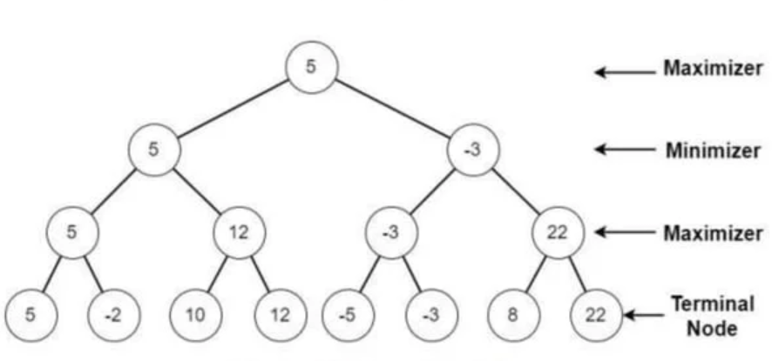
- Show how Alpha-Beta pruning reduces nodes in above tree.
- Write a short note on expert system Mycin.

